# LAB # 08

**LAB TASKS 1:**

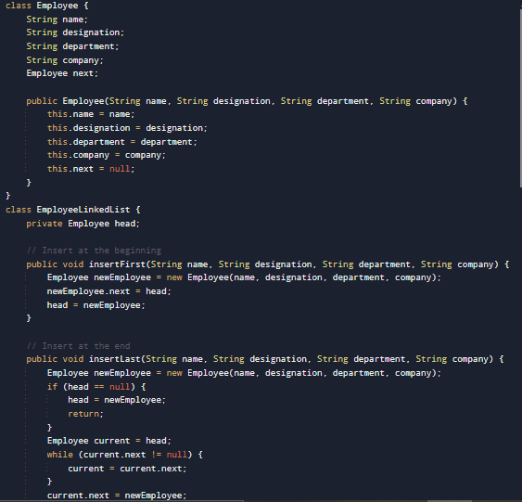

**OUTPUT**

**LAB TASKS 2:**

**OUTPUT**

**LAB TASKS 3:**

**OUTPUT**

**HOME TASK :**

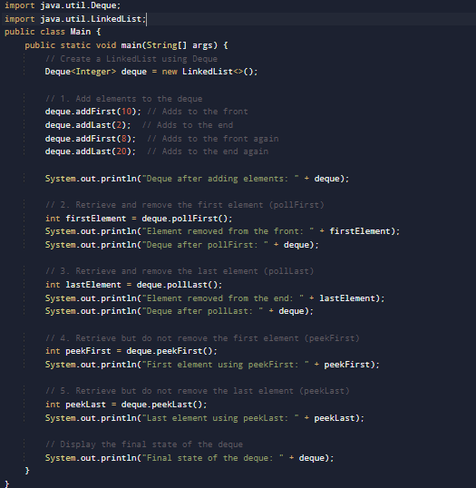

**OUTPUT**

